... 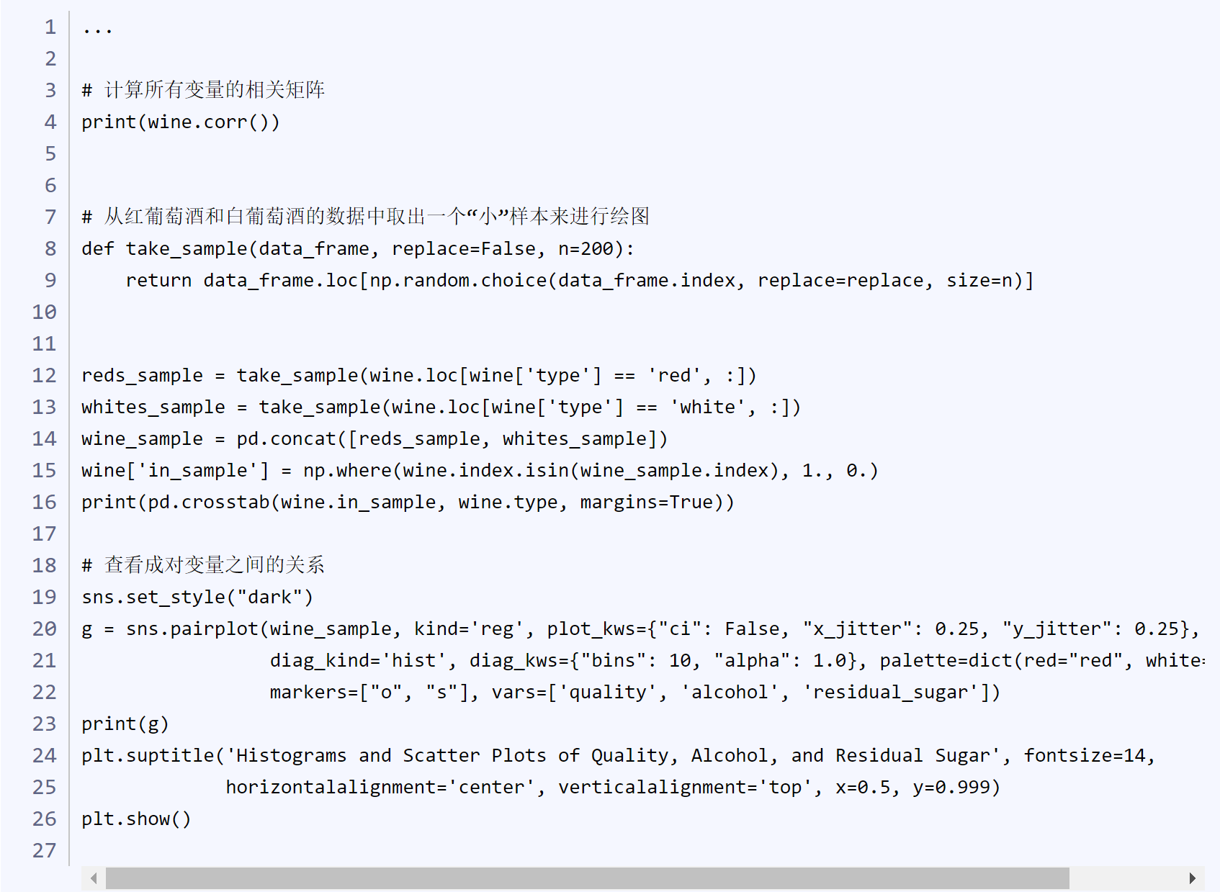

# 计算所有变量的相关矩阵

print(wine.corr())

# 从红葡萄酒和白葡萄酒的数据中取出一个“小”样本来进行绘图

def take_sample(data_frame, replace=False, n=200):

return data_frame.loc[np.random.choice(data_frame.index, replace=replace, size=n)]

reds_sample = take_sample(wine.loc[wine['type'] == 'red', :])

whites_sample = take_sample(wine.loc[wine['type'] == 'white', :])

wine_sample = pd.concat([reds_sample, whites_sample])

wine['in_sample'] = np.where(wine.index.isin(wine_sample.index), 1., 0.)

print(pd.crosstab(wine.in_sample, wine.type, margins=True))

# 查看成对变量之间的关系

sns.set_style("dark")

g = sns.pairplot(wine_sample, kind='reg', plot_kws={"ci": False, "x_jitter": 0.25, "y_jitter": 0.25}, hue='type',

diag_kind='hist', diag_kws={"bins": 10, "alpha": 1.0}, palette=dict(red="red", white="white"),

markers=["o", "s"], vars=['quality', 'alcohol', 'residual_sugar'])

print(g)

plt.suptitle('Histograms and Scatter Plots of Quality, Alcohol, and Residual Sugar', fontsize=14,

horizontalalignment='center', verticalalignment='top', x=0.5, y=0.999)

plt.show()

代码运行的结果如下：

